Possible connection
-Life Scientist as Global Technical Support (m|f|d)
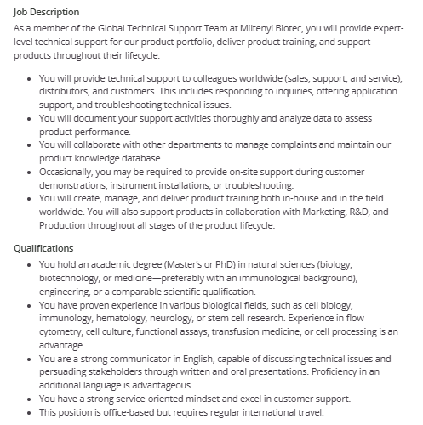

-Senior Clinical Scientist – Clinical Drug Development (m|f|d)
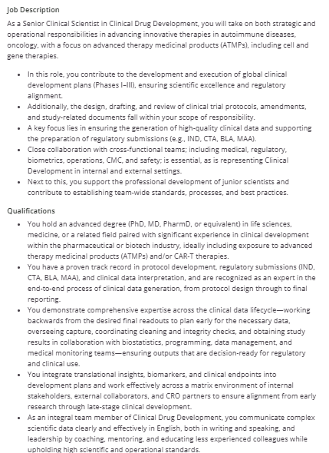

- Clinical Data Manager (m|f|d)
-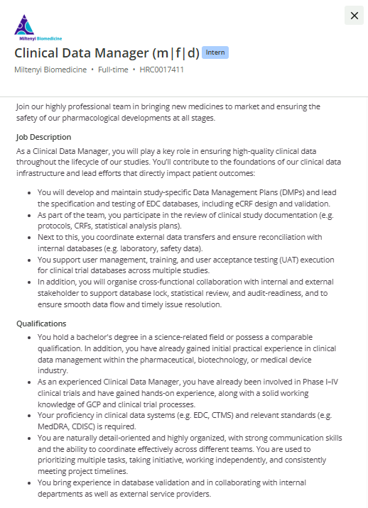

- Product Manager / Portfolio Expert (m|f|d) Immuno-Oncology
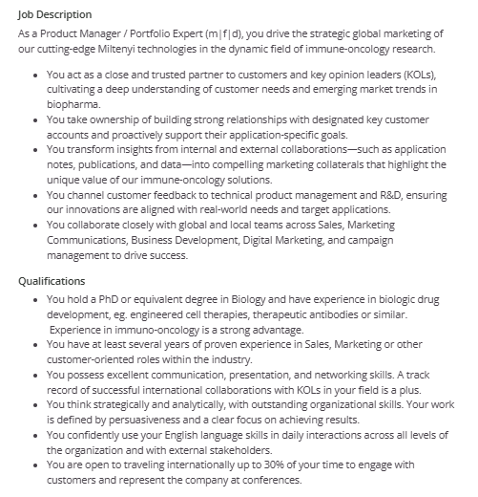

- Senior Clinical Translational Project Manager - CGT Drug Development (m|f|d)
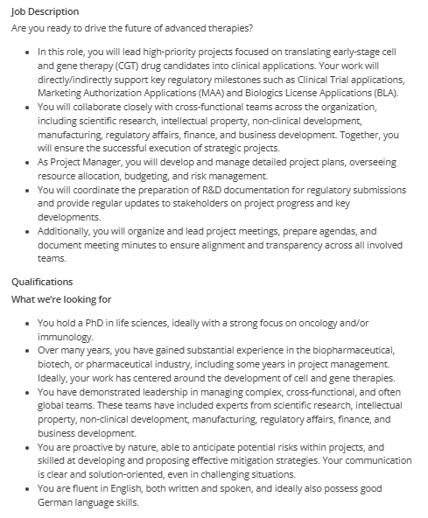

- Clinical Account Manager (m|f|d) - Barcelona-based
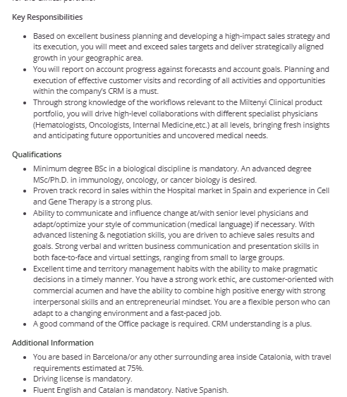

- Life Scientist as Global Technical Support Manager – Research portfolio (m|f|d)
